


Procedure Manual for Distrist Health Information System 2 DHIS2(Reporting Tools)


Table of Contents
Facility Identification (DHIS2- Daily- Sec. I) 3
Outpatient Department (OPD) Register (DHIS2- Daily- Sec. II) 4
Indoor Services Register (DHIS2- Daily- Sec. III) 6
Cases Attended Indoor Register (DHIS2- Daily- Sec. IV) 7
Surgeries (from OT register) (DHIS2- Daily- Sec. V) 8
Maternal and Newborn Health Register (DHIS2- Daily- Sec. VI) 9
Family Planning Register (DHIS2- Daily- Sec. VII) 10
Immunization interfaced from EPI MIS (DHIS2- Daily- Sec. VIII) 12
Diagnostic Services (From Lab register/ TB Lab Register/ Radiology Register) (DHIS2- Daily- Sec. XIII) 13
Laboratory Investigation for Communicable Diseases (DHIS2- Daily- Sec. XIV) 14
Physiotherapy Service Provision (DHIS2- Daily- Sec. XV) 14
Afghan Refugees (DHIS2- Daily- Sec. XVI) 15
Community Meeting Register (DHIS2- Monthly- Sec. IX) 16
Stock report: Stock position of drugs (From Stock register for Medicine/Supplies) (DHIS2- Monthly- Sec. X) 17
Stock Report: Vaccine (stock position of vaccine) Register (DHIS2- Monthly- Sec. XI) 18
Family Planning Commodities (From FP Register) (DHIS2- Monthly- Sec. XII) 19
TB-DOTS Data during a Month (DHIS2- Monthly- Sec. XV) 20
Human Resource Data (From Facility Record) (DHIS2- Monthly- Sec. XVI) 21
Revenue Generated (DHIS2- Monthly- Sec. XVII) 22
Financial Report for the Current Fiscal Year (DHIS2- Monthly- Sec. XVIII) 23
WATER, SANIATAION, HYGIENE, GRIEVANCES REDRESSEL MECHANISM (GRM), JANITORIAL & SECURITY SERVICES (DHIS2- Monthly- Sec. XIX) 24
Assistive Product Services (DHIS2- Monthly- Sec. XX) 25
Inventory Sheet for Equipment Available At Various Facilities (DHIS2- Quarterly- Sec. XXI) 26
ANNEX 1: Case Definitions: 28

Abbreviations:
OPD: Out Patient Department
LA: Local Anesthesia
Hb: Hemoglobin
ANC: Antenatal Care
PNC: Postnatal Care
MO: Medical Officer
WMO: Woman Medical Officer
LHV: Lady Health Visitor
FHT: Family Health Technician
IUCD: Intra Uterine Contraceptive Device
EDD: Expected Delivery Date
EPI: Expanded Programme on Immunization
BCG: Bacillus Calmette–Guérin for TB
OPV: Oral poliovirus vaccines
PCV: pneumococcal conjugate vaccine
Penta Vaccine: Diphtheria, Pertussis, Tetanus, Hepatitis B and Hib (Haemophilus influenzae type B)
TT and TD: Tetanus Toxoid and Tetanus-Diphtheria
MR Vaccine: Mumps and Rubella
IPV: Inactive Polio Vaccine
MTB: Mycobacterium Tuberculosis
AFB: Acid-Fast Bacteria
MP: Malaria Parasites
TB DOT: Tuberculosis Direct Observe Therapy
HBV, HCV: Hepatitis B Virus, Hepatitis C Virus

Facility Identification (DHIS2- Daily- Sec. I)

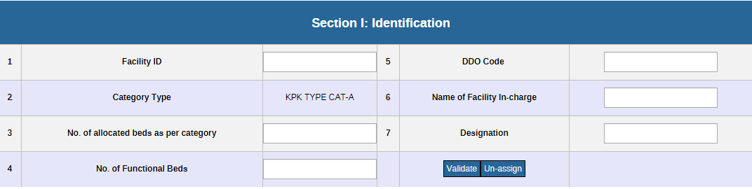

Who will fill: Data entry operator and District user after validation of the dataset.

Instruction for filling the register:
Row 1, Facility ID: Facility ID will be Auto-generated by the system
Row 2, Category Type: Category type of the facility will be Auto-generated by the system
Row 3, No. of allocated beds as per category: Mention the total no. of allocated beds present in the facility
Row 4, No. of Functional Beds: Mention the no. of functional beds in the facility
Row 5, DDO code: DDO code will be Auto-generated by the system
Row 6, Name of Facility In-charge: Mention the name of facility in-charge
Row 7, Designation: Mention the designation of the health facility in-charge
Validation/Un-assign: Once the District Coordinator reviews and approves a form, the user can click the 'validate' button, which will indicate the compliance status of that particular district at the Provincial DHIS cell. This multi-tiered approach creates an approval layer that ensures thorough scrutiny of the forms at both the district and provincial levels. However, if any District Coordinator fails to validate a form, it triggers a compliance issue.

Outpatient Department (OPD) Register (DHIS2- Daily- Sec. II)
Who with enter the Data: The reporting tool (DHIS-2 Application) will be filled by Health facility focal person.
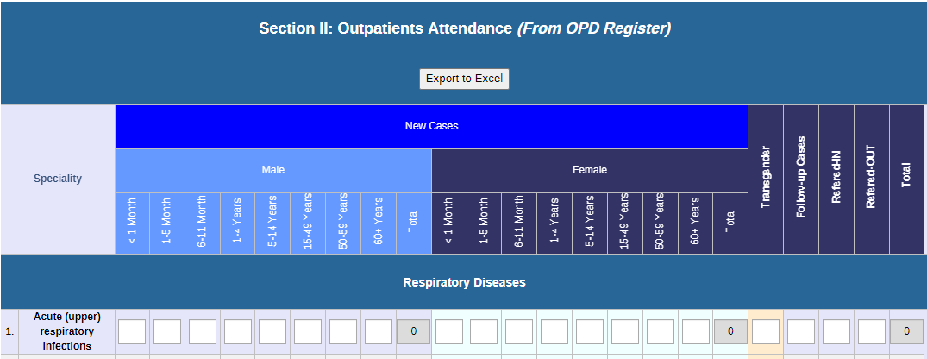

Instructions for filling the columns of the OPD register
There are 22 columns in the OPD Register that are spread over two adjacent pages. During interactions with the patients, entries are made in Columns No. 1-22 depending upon whether the patient is a new patient or a follow-up case. For new cases, entries are required to be made in all the columns except Column No. 19.
Daily Reporting:
Column 1: Specialty: The column contains a list of selected diseases for which morbidity and mortality data are collected, compile, and reported every day. The list of reportable diseases is arranged by specialty, e.g., respiratory, gastrointestinal tract, urinary tract, obstetrics, gynecology, pediatrics, etc. Each OPD will complete only that part of the abstract form which is relevant to its specialty.
The daily number will provide an up-to-date total of all new patients/clients attending a particular OPD point for the day; the monthly and yearly totals (Reports) can also be calculated using the DHIS2 tool.
If more than one OPD points are functional at the facility, each point will maintain separate daily serial numbers for patients attending that particular OPD point.
Columns 2-16: Age Category: These columns are to record the age group of the new patient according to his/her sex (Male/Female/Transgender).
Column 17: Transgender Put the number of transgender patients in this column if the patient is transgender.
Column 18: Follow-up case Write the total number all follow-up cases, i.e. patients returning with the continuation of the same disease with previous record e.g. OPD slip.
Column 19: Referred In Mention the number of patients referred from another facility to this facility.
Column 20: Referred Out Mention the number of patients referred from this facility to any other facility

Indoor Services Register (DHIS2- Daily- Sec. III)
The Indoor Register is maintained indoors of the facility for recording the total beds capacity, LAMA, admissions, and discharge in the inpatient departments (indoors) of the hospital.
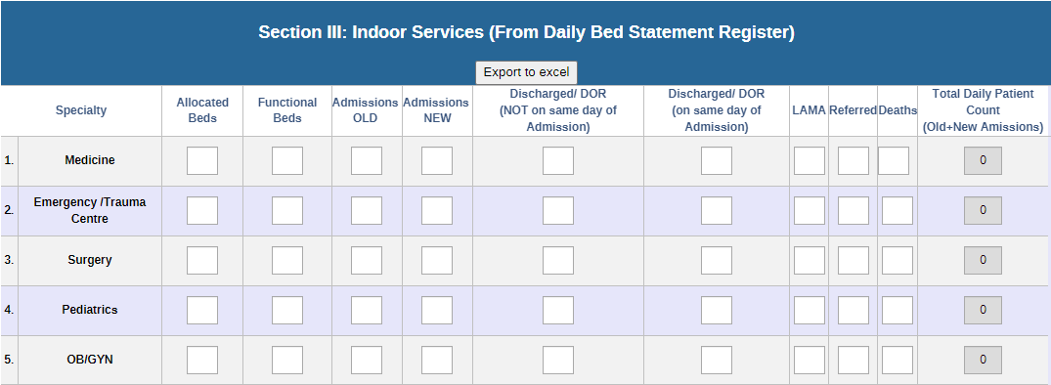
When filled: At the end of each day
Who will enter the Data: The reporting tool (DHIS-2 Application) will be filled by Health facility focal person
Columns 2 and 3: Allocated Beds and Functional Beds write the total number of beds allocated to the particular ward and write the functional bed in column 3 of the register.
Column 4 and 5: Total Admission write the total number of admissions, old admission in column no 4 and new admission in column no 5 in the given day
Columns 6 and 7: Discharge (not on the same day of admission) or DOR (on the same day of admission) write the total number of DOR not on the same day in column 6 and DOR on the same day in column 7
Columns 8-10 LAMA, Referred and Death: write the total number of LAMA cases in column 8, the total number of referred cases in column 9, and the total deaths in column 10 in the given time.
Columns 11: Total Daily Patients Count (old and new admission) write the total patient count for old admitted or new admission in column 11.

Cases Attended Indoor Register (DHIS2- Daily- Sec. IV)
Reporting Tool for CAI:
The case attended indoor Register is maintained indoors of the facility for recording all the admissions and deceased patients in the inpatient departments (indoors) of the ward or facility.
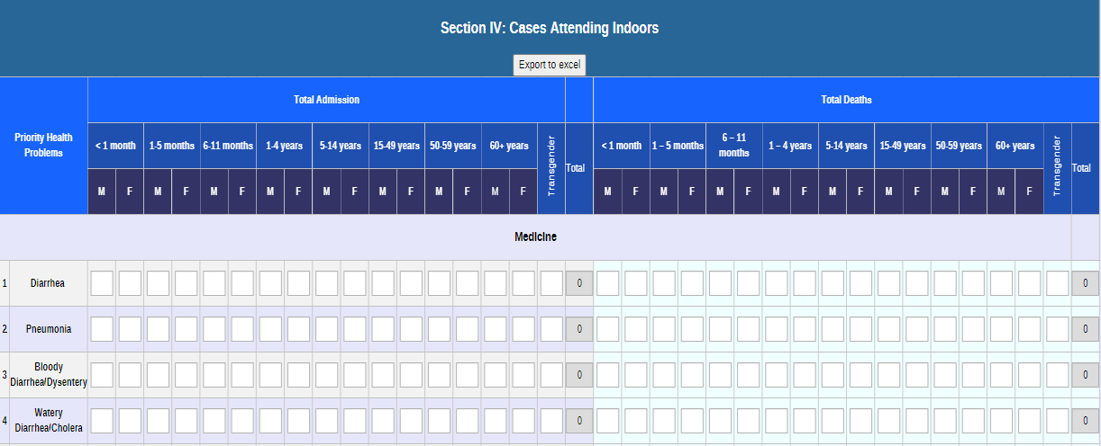
When filled: At the end of each day.
Who will enter the Data: The reporting tool (DHIS-2 Application) will be filled by Health facility focal person.
Column 1: Priority health problem contains the list of diseases
Column 2: Total admission; These sub-columns are to record the age group of the admitted patient according to his/her sex (Male/Female/Transgender). Write the total number in the appropriate sub-column according to the patient’s age and sex.
Column 3: Total Deaths, the sub-columns are to record the age group of the deceased patient according to his/her sex (Male/Female/Transgender). Write the total number the in appropriate sub-columns according to the patient’s age and sex.

Surgeries (from OT register) (DHIS2- Daily- Sec. V)
When filled: Daily after compiling all OT registers in the health facility
Who will enter the data: The reporting tool (DHIS-2 Application) will be filled by Health facility focal person

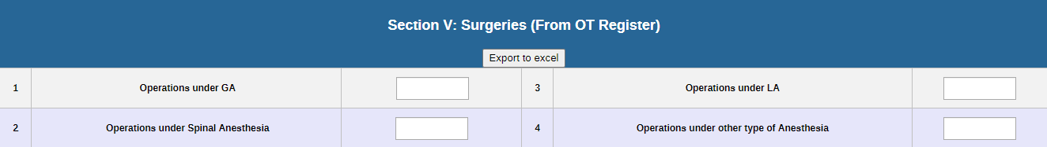
- General Anesthesia (GA): write the number of surgeries done under general anesthesia in serial 1
- Spinal Anesthesia: write the number of surgeries done under spinal anesthesia in serial 2
- Local Anesthesia (LA): write the number of surgeries done under local anesthesia in serial 3
- Others/None: write the number of surgeries done using other form of anesthesia in serial 4

Maternal and Newborn Health Register (DHIS2- Daily- Sec. VI)
When filled: Daily, after compiling all the data from maternal health register at the end of the day.
Who will enter the data: The reporting tool (DHIS-2 Application) will be filled by Health facility focal person
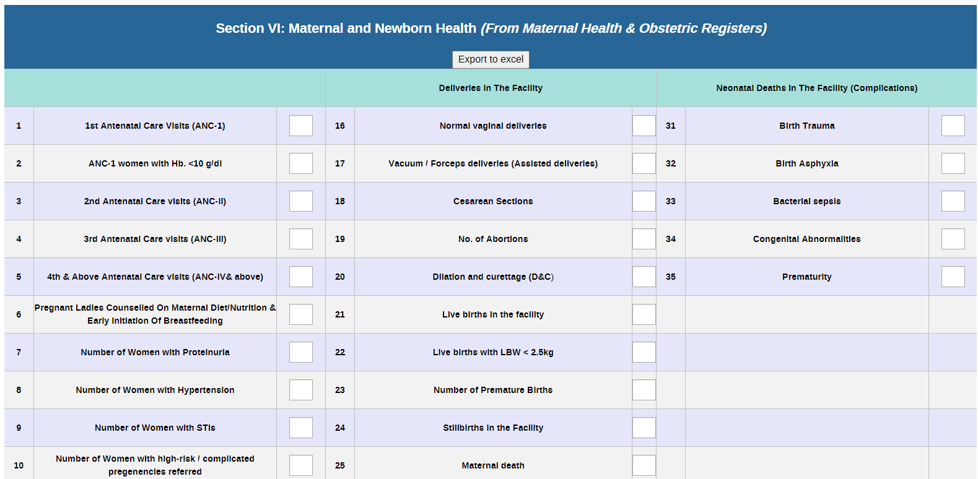
Instructions for completing the columns of the register
Section 1: There are 15 rows for recording the findings of antenatal (ANC) visits by the pregnant woman. In each row of section 1, write the number antenatal visit in each row accordingly. The hemoglobin (Hb) level of every pregnant woman coming for the first antenatal service (ANC1) and, thereby, getting registered with the facility for the first time must be recorded. Record the hemoglobin level in this column and if the hemoglobin (Hb) level is less than 10g/dl, add the total in the 2nd row, write the total number of Pregnant Ladies Counselled On Maternal Diet/Nutrition & Early Initiation Of Breastfeeding in row 6, the number of women with proteinurea in row 7, number of women with Hypertension in row 8, total number of women with STIs in row 9, Number of Women with high-risk / complicated pregnancies referred in row 10, Number of Pregnant women who Received IRON/FOLIC ACID Supplementation in row 11 and 1st postnatal care visit in the facility and total revisit for PNC in row 12 and 13, Number of Women with Postnatal complications (Postpartum Hemorrhage, Postpartum Sepis) Referred in row 14 and Malnourished Lactating women (PNC-1) in row 15 of section 1.
Section 2: Deliveries in the facility Write the total number of deliveries in a facility in the appropriate row 16-18 according to the nature/mode of delivery, total number of abortions in row 19, total number of D and Cs in row 20, row 21 the number of live birth in the facility, row 22 the number of live with weight less than 2.5kg, total number of premature birth in row 23, total still birth in the facility in row 24, total no of maternal death in row 25, number of intra-uterine death in row 26, number of birth trauma cases in row 27, neonate receive skin to skin contacts in row 28, number of Neonate initiate BF in one hour in row 29, neonate receive CHX in row 30.
Section 3: Neonatal death in the facility (complications) Fill in the number of newborn child dies due to birth trauma in row 31, dies due to bacterial sepsis in row 32, Birth Asphyxia in row 33, congenital abnormalities in row 34 and numbers of newborn child dies of prematurity in row 35.

Family Planning Register (DHIS2- Daily- Sec. VII)
When filled: Daily, after compiling all the data from FP register at the end of the day.
Who will enter the data: The reporting tool (DHIS-2 Application) will be filled by Health facility focal person
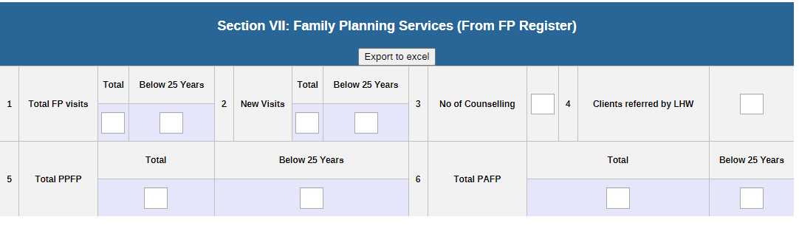
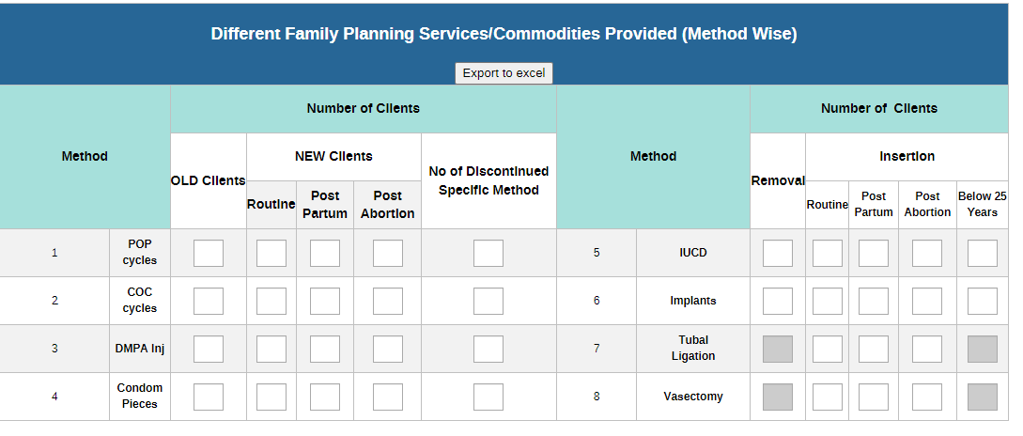
Total FP visits: write the total number of visits recorded in the FP register under the 'Total' column, and tabulate the total count of client visits made by individuals under the age of 25 in the 'Below 25 years' column.
New Visits: write the total number of new visits recorded in the FP register under the 'Total' column, and tabulate the total count of client visits made by individuals under the age of 25 in the 'Below 25 years' column.
No. of FP counselling: write the total number of FP counselling in column 3 from FP register.
Client Referred by LHW: write the total number of client referred by LHW in column 4 from FP register.
Total Post-Abortion Family Planning: write the total number of Post-Abortion visit (PAFP) recorded in the FP register under the 'Total' column, and tabulate the total count of client visits made by individuals under the age of 25 in the 'Below 25 years' column.
Total post-partum Family Planning: write the total number of Post-partum visit (PPFP) recorded in the FP register under the 'Total' column, and tabulate the total count of client visits made by individuals under the age of 25 in the 'Below 25 years' column.
Methods for FP (serial numbers 1-8)
Write in the total number according to the service provided to the FP client. Write the total number women receiving the services, regular clients in the old column, and newcomers in a new column according to the relevant category ‘Routine’ or ‘post-partum’ or ‘post- abortion’ or the client who have discontinued that specific method
Row 1-4:
- Total number of lactating mothers who are given progesterone-only pills (POP), regular clients in the old column, and newcomers in a new column according to the relevant category ‘Routine’ or ‘post-partum’ or ‘post- abortion’ or the client who have discontinued that specific method
- If a contraceptive injection (i.e., DMPA) has been given to the client, write the total number of regular clients in the old column and newcomers in a new column according to the relevant category ‘Routine’ or ‘post-partum’ or ‘post- abortion’ or the client who have discontinued that specific method
- If IUD is inserted during the visit write the total number of regular clients in the old column and newcomers in a new column according to the relevant category ‘Routine’ or ‘post-partum’ or ‘post- abortion’ or the client who have discontinued that specific method
- If condoms are provided, write the number of condom pieces in the respected column, regular client in the old column, and newcomer in a new column according to the relevant category ‘Routine’ or ‘post-partum’ or ‘post- abortion’ or the client who have discontinued that specific method

Row 5 and 6 if implant/IUDC is inserted:

- write the total number of regular clients who will remove in ‘remove column’ and the insertion of implant or IUDC according to the relevant category ‘Routine’ or ‘post-partum’ or ‘post- abortion’ or ‘the client who’s age is below 25 years’

Row 7 and 8 If tube ligation/vasectomy:
- write the total number of clients for tube ligation or vasectomy according to the relevant category ‘Routine’ or ‘post-partum’ or ‘post- abortion’

Immunization interfaced from EPI MIS (DHIS2- Daily- Sec. VIII)
When to fill: Daily or at the time the EPI schedule for vaccination
Who will enter the data: The reporting tool (DHIS-2 Application) will be filled by Health facility focal person
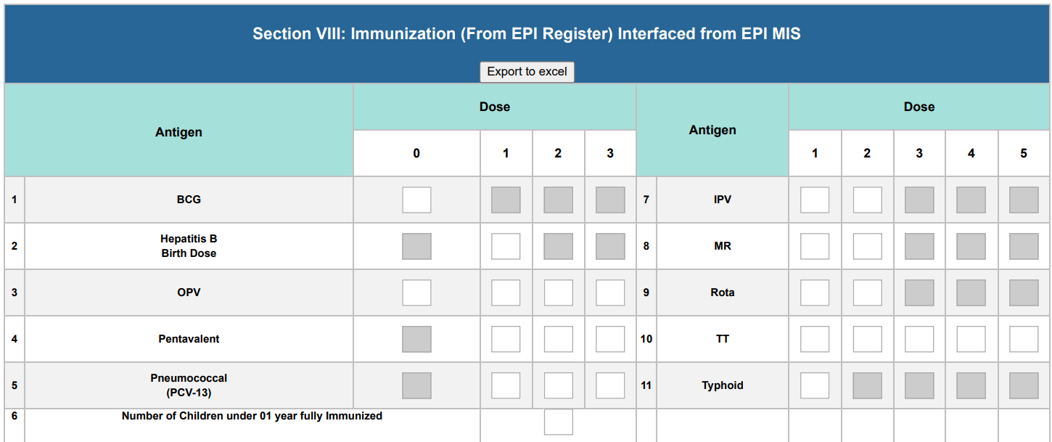
Instructions for filling out the immunization register
Columns 1 and 3: Antigens 1-10 antigens are listed
Columns 2 and 4: Columns are mentioned according to the number of doses of the given vaccine 1-3 or 1-5 the grey area is blocked for user entry because for some vaccines just one dose is recommended while for the other two or 3 depending upon the type of vaccine. Below is the vaccination table according to age.
Birth | OPV 0, BCG
6 weeks | OPV I, Penta I, PCV I
10 weeks | OPV II, Penta II, PCV II
14 weeks | OPV III, Penta III, PCV III
9 months | Measles I
15 months | Measles II
B/w 4 weeks & 12 months | IPV
9 to 24 months, time, if missed, can be given till 5 years | MR vaccine
15 months | Rota vaccine
4 months, booster dose at 3 and 14 years, and during pregnancy | TT/ TD vaccine
2 years and after every 2 years for people who remain at risk | Thyroid

Diagnostic Services (From Lab register/ TB Lab Register/ Radiology Register) (DHIS2- Daily- Sec. XIII)
When filled: Daily, after the compilation of all the data from the recording tool.
Who will enter the data: The reporting tool (DHIS-2 Application) will be filled by Health facility focal person
Instructions for filling data in the diagnostic services register

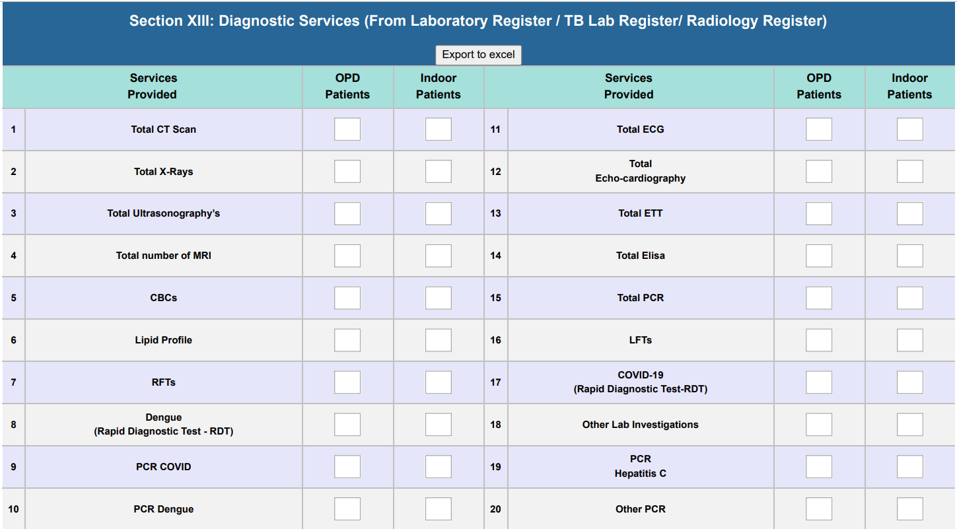
Services provided at the facility
OPD Patient: The total number of OPD patients who have availed of the services provided at the facility.
Indoor patient: Mention the total number of indoor patients who have availed of the services provided in the facility.

Laboratory Investigation for Communicable Diseases (DHIS2- Daily- Sec. XIV)
When filled: Daily, after compiling all the data from the recording tool.
Who will enter the data: The reporting tool (DHIS-2 Application) will be filled by Health facility focal person

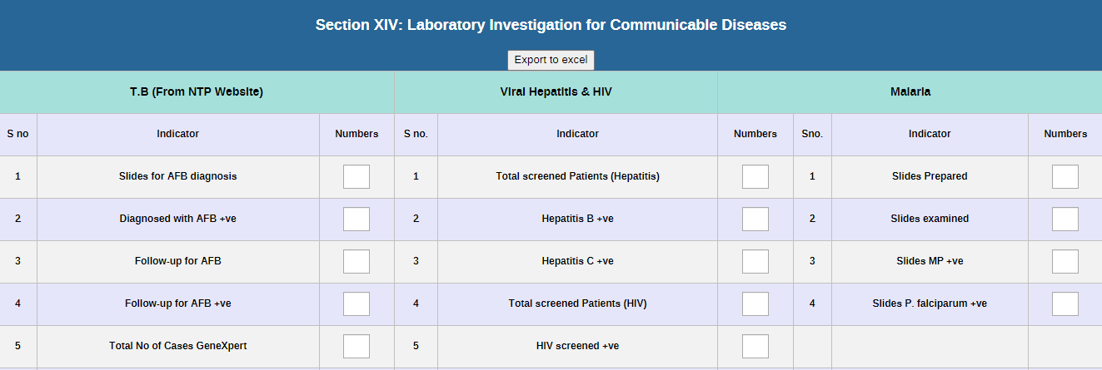
Column 3: of each communicable disease Count the total number of patients for each communicable disease test and fill in the total number of lab investigations done in column 3 against the name of the corresponding test.

Physiotherapy Service Provision (DHIS2- Daily- Sec. XV)
When filled: Daily, after compiling all the data from the recording tool.
Who will enter the data: The reporting tool (DHIS-2 Application) will be filled by Health facility focal person
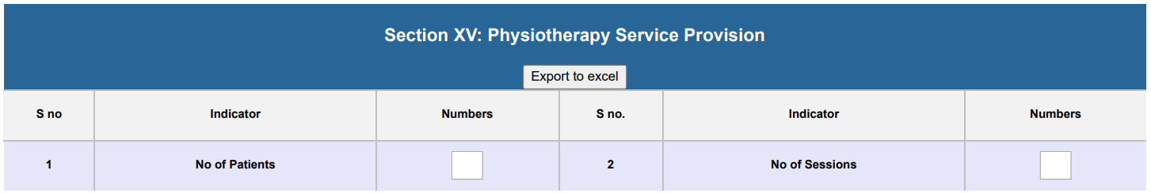
Column 3: Record the total number of patients utilizing physiotherapy services.
Column 6: Write the daily count of physiotherapy sessions given in the facility.

Afghan Refugees (DHIS2- Daily- Sec. XVI)
When filled: Daily, after compiling all the data from the recording tool.
Who will enter the data: The reporting tool (DHIS-2 Application) will be filled by Health facility focal person
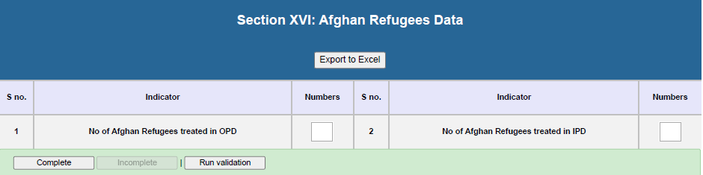
Column 3: Record the total number of Afghan refugee patients utilizing the OPD services.
Column 6: Record the total number of Afghan refugee patients utilizing the IPD services.

Community Meeting Register (DHIS2- Monthly- Sec. IX)
When filled: At the end of each month
Who will enter the data: The reporting tool (DHIS-2 Application) will be filled by Health facility focal person

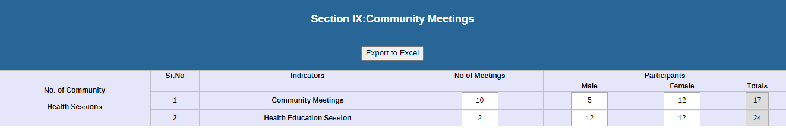
Instructions for filling data in the register
There are 5 columns in the Community Meeting Register.
Column 1: no of community health sessions in the facility.
Columns 2: Serial number:
Column 3: Indicators, there are two types of sessions 1st for community meetings, 2nd for a health education session
Column4: Write number of meetings and health education session in relevant column
Column 5: Note down the number of male participants in the Male column and female participants in the Female column and the total of males and females of each session in the total column.

Stock report: Stock position of drugs (From Stock register for Medicine/Supplies) (DHIS2- Monthly- Sec. X)
When filled: At the end of each month
Who will enter the data: The reporting tool (DHIS-2 Application) will be filled by Health facility focal person
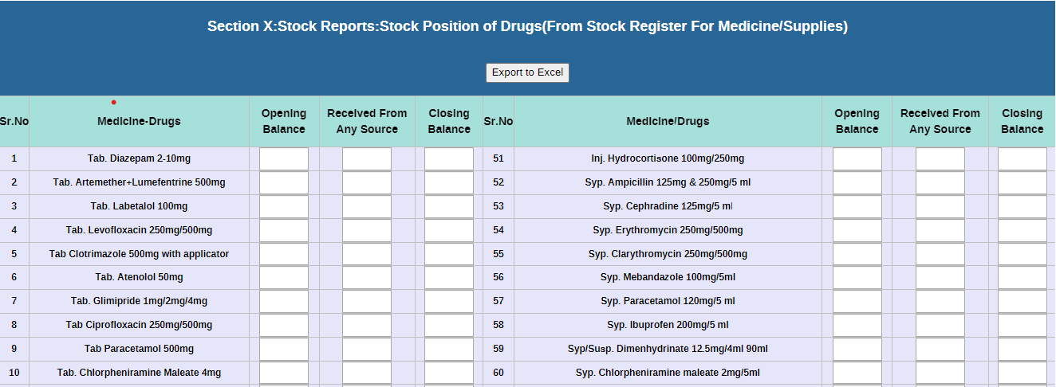
Opening Balance: Mention the quantity of each medicine available at the store at the start of each month
Received: Mention the quantity of each medicine received
Closing balance: Closing balance will be calculated automatically. This closing balance will be the opening balance for the next month.

Stock Report: Vaccine (stock position of vaccine) Register (DHIS2- Monthly- Sec. XI)
When filled: At the end of each month
Who will enter the data: The reporting tool (DHIS-2 Application) will be filled by Health facility focal person
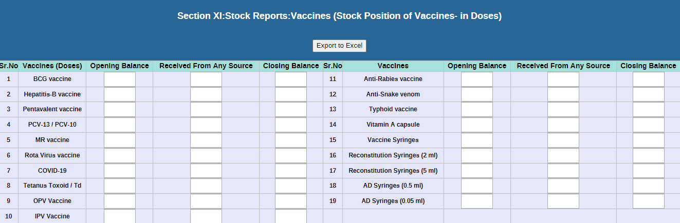
Opening Balance: Mention the quantity of each medicine available at the store at the start of each month
Received: Mention the quantity of each medicine received
Closing balance: Closing balance will be calculated automatically. This closing balance will be the opening balance for the next month.

Family Planning Commodities (From FP Register) (DHIS2- Monthly- Sec. XII)
When filled: At the end of each month
Who will enter the data: The reporting tool (DHIS-2 Application) will be filled by Health facility focal person
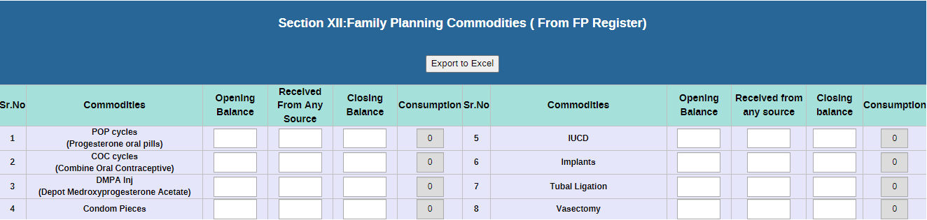
Opening Balance: Mention the quantity of each medicine available at the store at the start of each month
Received: Mention the quantity of each medicine received
Closing balance: Closing balance will be calculated automatically. This closing balance will be the opening balance for the next month.

TB-DOTS Data during a Month (DHIS2- Monthly- Sec. XV)
When filled: At the end of each month
Who will enter the data: The reporting tool (DHIS-2 Application) will be filled by Health facility focal person
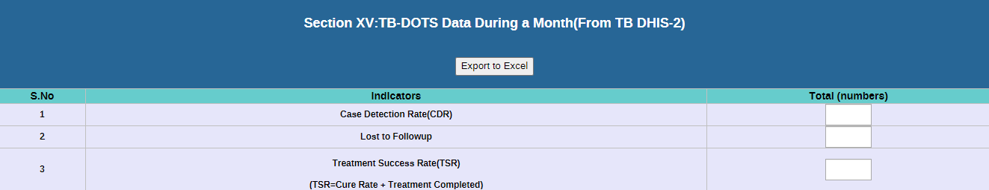
Data will auto fetch from TB MIS.

Human Resource Data (From Facility Record) (DHIS2- Monthly- Sec. XVI)
When filled: At the end of each month
Who will enter the data: The reporting tool (DHIS-2 Application) will be filled by Health facility focal person
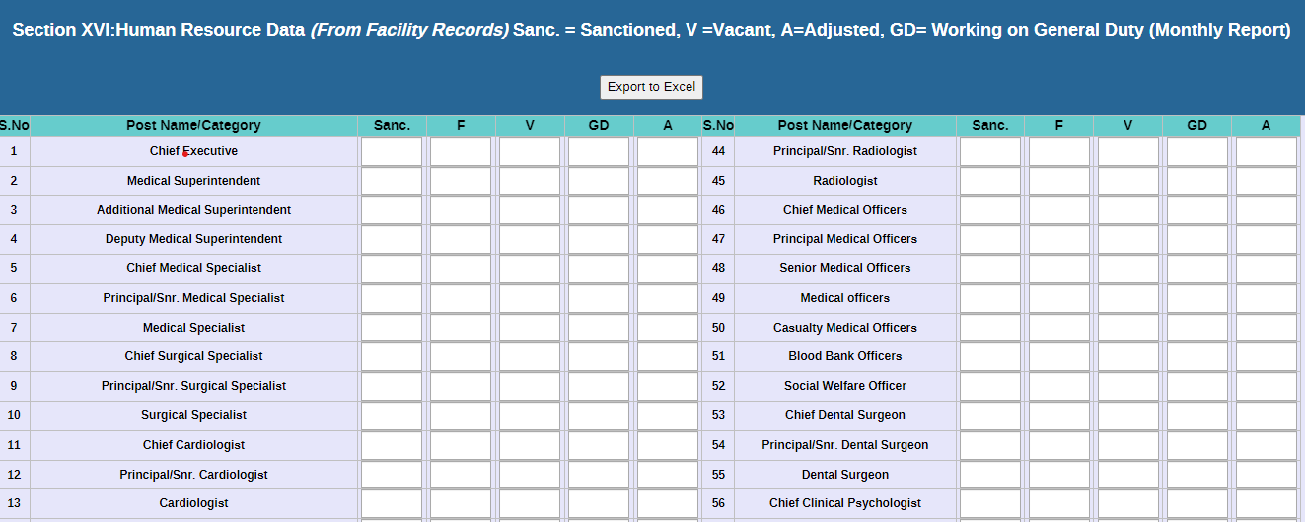
Instructions for filling data in the HR Data register
Columns 1 and 7: post name/category
Columns 2-6 and 8-12: Fill in the appropriate column according to the post position columns 2 and 8 for Sanc. = total sanctioned posts, columns 3 and 9 for F= total filled vacancies or faculty at present, columns 4 and 10 for v= total number of vacant posts, columns 5 and 11 for GD= number general duty post, and columns 6 and 12 for A= adjusted post in the facility.

Revenue Generated (DHIS2- Monthly- Sec. XVII)
When filled: At the end of each month
Who will enter the data: The reporting tool (DHIS-2 Application) will be filled by Health facility focal person
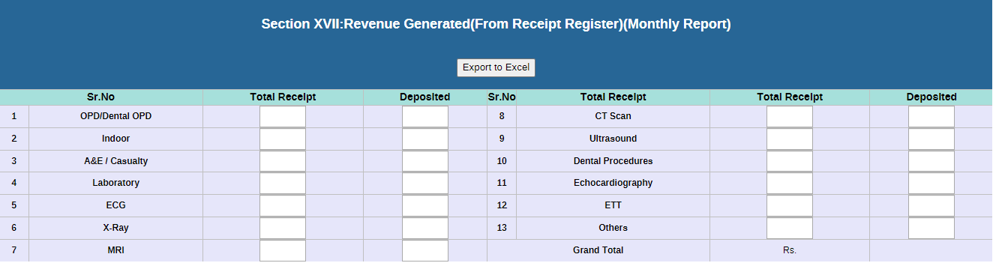
Instructions for filling the revenue-generated register
Column 2: Total receipt Write down the number of total receipts received at the end of each month.
Column 3: Deposited Write down the total amount received from each procedure in a particular row and the grand total in the last row

Financial Report for the Current Fiscal Year (DHIS2- Monthly- Sec. XVIII)
When filled: At the end of each month
Who will enter the data: The reporting tool (DHIS-2 Application) will be filled by Health facility focal person
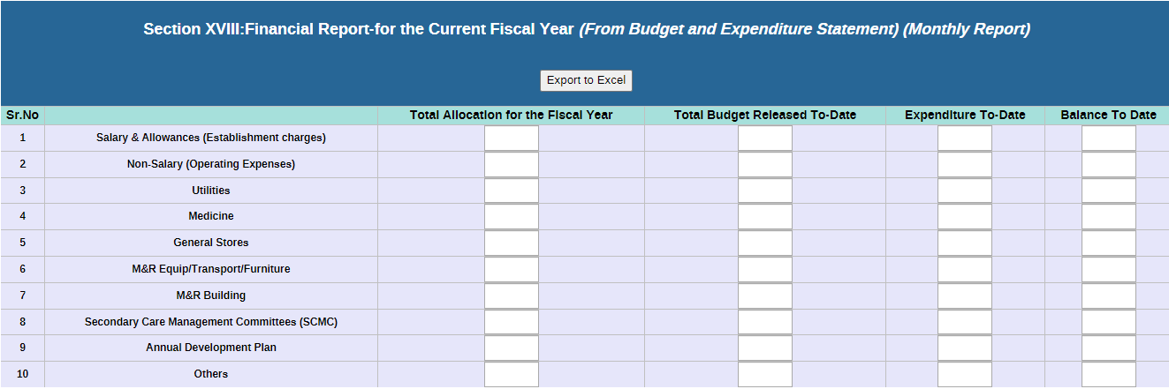
Instructions for filling data in the financial report register
Column 2: Total Allocation for the Fiscal Year Write the total budget in rupees allocated for the current fiscal year.
Column 3: Total Budget Released to-date Write the total budget released till to date for the facility in rupees
Column 4: Expenditure to date Write the expenditure in rupees
Column 5: Balance to date Write the remaining balance available in rupees

WATER, SANIATAION, HYGIENE, GRIEVANCES REDRESSEL MECHANISM (GRM), JANITORIAL & SECURITY SERVICES (DHIS2- Monthly- Sec. XIX)
When filled: At the end of each quarter
Who will enter the data: The reporting tool (DHIS-2 Application) will be filled by Health facility focal person
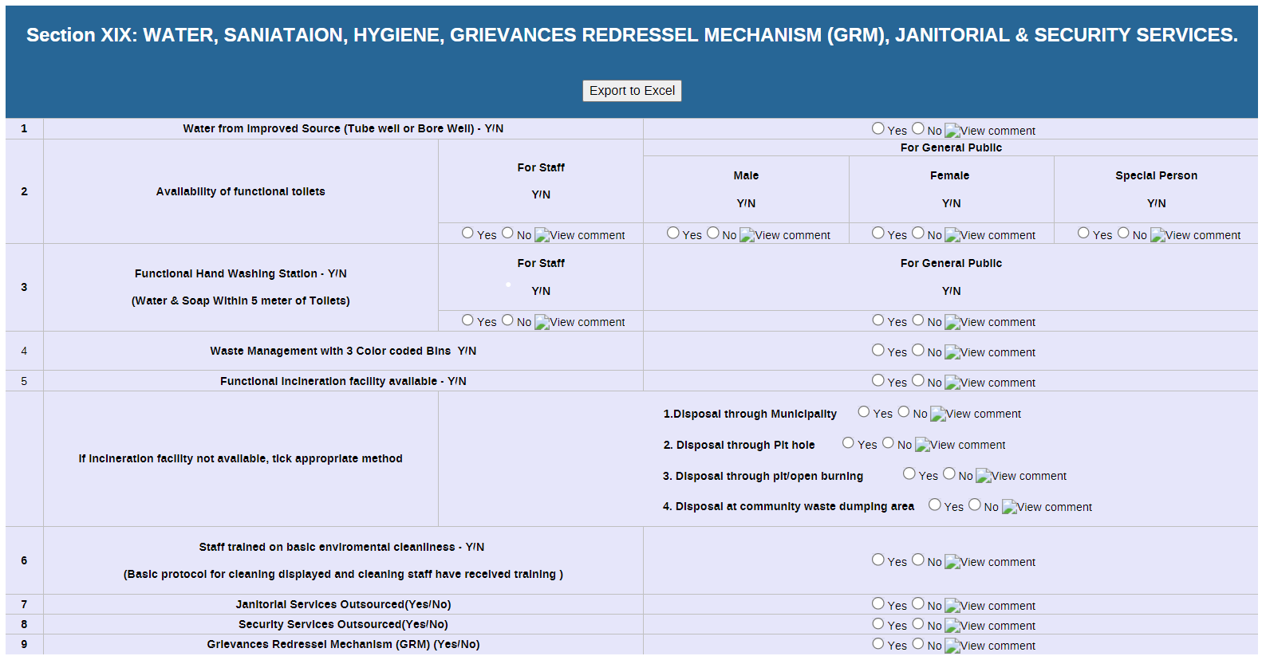
Instructions for filling data in the WASH register
Water from improved source: Write yes if the water source is available at the facility and no if not. If no why? Please add in comment
Availability of functional toilets: Fill in the relevant column with yes if the functional toilet is available and no if not available. If no why? Please add in comment
Functional Hand Washing Station: Write yes if function hand wash stations are available and no if not available. If no why? Please add in comment
Waste Management with 3 color-coded bins: Fill in the column with yes if 3 colors bins are available and no if not provided in the facility. If no why? Please add in comment
Incineration facility: Write yes if the incineration facility is available and if not available please tick the appropriate option of incineration in the facility. If no why? Please add in comment
Staff training on basic environment cleanliness: Write yes if staff training is given in the facility on basic environment cleanliness and no if not available. If no why? Please add in comment
Janitorial Services Outsourced (Yes/No): Write yes if the janitorial services outsourced and write no if it is not outsourced.
Security Services Outsourced (Yes/No): Write yes if the security services outsourced and write no if it is not outsourced.
Grievances Redresser Mechanism (GRM) (Yes/No): Write yes if the Grievances Redresser Mechanism GRM is available in the facility is available and write no if not available.

Assistive Product Services (DHIS2- Monthly- Sec. XX)
When filled: At the end of each month
Who will enter the data: The reporting tool (DHIS-2 Application) will be filled by Health facility focal person
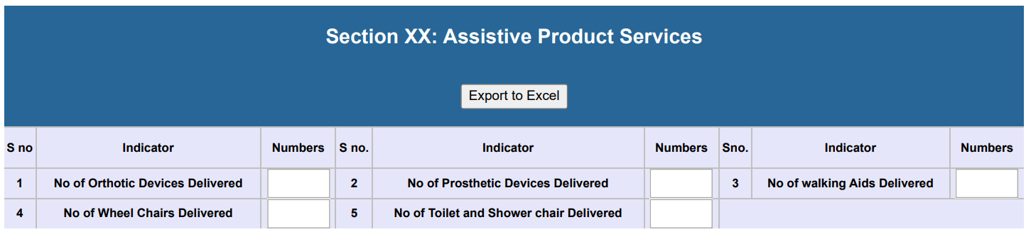
Row 1: No. of Orthotic Devices Delivered: Record the number of orthotic devices provided to the facility during the specified month in column 3.
Row 2: No. of Prosthetic Devices Delivered: Record the number of prosthetic devices provided to the facility during the specified month in column 3.
Row 3: No. of Walking Aids Delivered: Record the number of walking aids provided to the facility during the specified month in column 6.
Row 4: No. of Wheel Chairs Delivered: Record the number of wheel chairs provided to the facility during the specified month in column 6.
Row 5: No. of Toilet and Shower Chairs Delivered: Record the number of toilet and shower chairs provided to the facility during the specified month in column 9.

Inventory Sheet for Equipment Available At Various Facilities (DHIS2- Quarterly- Sec. XXI)
Stock Register (Equipment/Furniture/Linen) The Stock Register (Equipment/Furniture/Linen) is intended for recording the movement of equipment/furniture/linen in and out of the facility store.
When filled: At the end of each Quarter
Who will enter the data: The reporting tool (DHIS-2 Application) will be filled by Health facility focal person
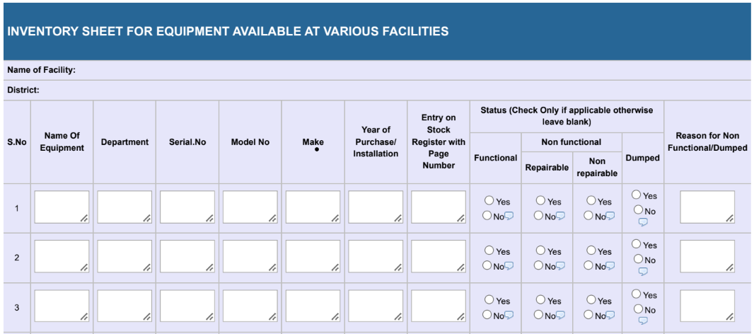
Instructions for filling the inventory sheet for the equipment register
S.no Write in this column the serial number for each entry.
Name of the equipment Write the name of the equipment present at the facility
Department Write the department name where the equipment is present
Write the serial number of the equipment if there is more than one piece of equipment of the same type then mention the serial number of each in this column
Model No Mention in column 5, made by in column 6, and year in which the equipment was made in column 7.
Entry on stock register with page no. Write the page number from the register provided
Status Please mention the status of the equipment in the sub-column as mentioned below the status according to the condition of the equipment whether it’s functional, repairable, non-repairable, or dumped.
Reason write the reason why non-repairable or dumped.
Status Write the number of articles in the store that are repairable in Column No. 8, and record the number of articles in the store that are unserviceable but have not been declared condemnable by the competent authority in Column No. 9.
Columns 10-11: After each transaction, the store-keeper will sign in Column No. 10; and after verification of the transaction, the facility in charge will countersign in Column No.11.
Column 12: Remarks This column is for recording any remarks by the store-keeper, facility in-charge or district supervisor may have regarding the transaction and the condition of the store.

ANNEX 1: Case Definitions:
S.NO | DISEASES/ CONDITION | CASE DEFINITIONS
 | Acute Flaccid Paralysis (AFP) | Sudden onset of paralysis/ weakness in any part of the body of a child less than 15 years of age due to any cause including GBS OR any person of any age with paralytic illness if polio is suspected
 | Acute Viral Hepatitis (A & E) | Any person having the acute onset of jaundice less than 1-month duration and severe illness (dark urine, fatigue, nausea, vomiting, and abdominal pain) and absence of any known precipitating factors
 | Acute Diarrhea (Non-Cholera) | An illness characterized by three or more loose, non-bloody stools in the last 24 hours with or without dehydration, in a person of any age
 | Acute watery Diarrhea- Suspected Cholera | Any patient of 2 years presenting with three or more watery, non-bloody stools (rice watery stools) in the last 24-hour, and severe dehydration or dying from acute watery diarrhea
 | Anthrax | Any case that is compatible with the clinical description of cutaneous, pulmonary, gastrointestinal, intentional, or meningeal Anthrax AND has an epidemiological link to confirmed or suspected animal cases or contaminated animal products
 | Bloody Diarrhea/ Dysentery | Any diarrheal episode with bloody mucoid, abdominal cramps, fever, and rectal pain
 | Brucellosis | A case with acute or insidious onset of fever, night sweats, undue fatigue, anorexia, weight loss, headache, and joint pain AND is epidemiologically linked to suspected or confirmed animal cases or contaminated food of animal origin
 | Chickenpox/ Varicella | Any person with prodromal symptoms (without macul-papulovesicular rash) at any part of the body and close contact with positive cases in the environment/ community
 | Chikungunya | Any person with acute onset of fever >38.5°C and severe arthralgia, myalgia not explained by other medical conditions
 | COVID-19 | Acute onset of ANY THREE OR MORE of the following signs or symptoms like fever, dry cough, general weakness/ fatigue, headache, myalgia, sore throat, coryza, dyspnea, anorexia/ nausea/ vomiting, and diarrhea, or having exposure to the known positive case/ residing in high transmission area within 14 days of the onset of symptoms
 | Crimean Congo Hemorrhagic  Fever (CCHF) | Acute onset of illness with high-grade fever (38.5°C) for > 3 days and < 10 days with any two of the following:  Hemorrhagic or purpuric rash, nose bleed, blood in vomit/ sputum/ stool, other hemorrhagic symptoms; and  No known predisposing factors for hemorrhagic manifestations  Among those in contact with a confirmed patient or handling animals and raw animal products  And when the fever does not respond to antibiotics or anti-malarial treatment
 | Dengue Fever | An acute febrile illness of 2-7 days duration with 2 or more of the following: headache, retro-orbital pain, myalgia (muscle pain), or arthralgia (joint pain)
 | Diphtheria (Probable) | An upper respiratory tract illness with an adherent membrane of the tonsils or larynx, pharynx, and/ or nose and one of the following: laryngitis, pharyngitis, or tonsillitis
 | Gonorrhea | A sexually transmitted infection commonly manifested by urethritis, cervicitis, or salpingitis (inflammation of the fallopian tubes)
 | HIV/AIDS | Any person with complaints of asymptomatic persistent generalized lymphadenopathy/ moderate unexplained weight loss, recurrent respiratory tract infections, recurrent oral ulceration, popular pruritic eruptions, fungal nail infections, and persistent diarrhea
 | ILI (Influenza-like illness) | Acute respiratory infection with a measured fever of 38°C with a cough
 | Leishmaniasis (Cutaneous) | The appearance of one or more lesions, typically on uncovered parts of the body; the face, neck, arms, and legs, which begins as nodules and turn into skin ulcers eventually healing but leaving a depressed scar
 | Leishmaniasis (Visceral) | A person with clinical symptoms of prolonged irregular fever, splenomegaly, and weight loss where fever lasts more than 2 weeks and does not respond to anti-malarial drugs
 | Leprosy | A person with loss of sensation and mobility to hand, feet, or face with symptoms like hypo-pigmented or reddish skin lesions or who has not completed a course of treatment
 | Malaria | Any person with fever or history of fever within the past 48 hours (with or without other symptoms such as nausea, vomiting and diarrhea, headache, back pain, chills, myalgia) in whom other obvious causes of fever have been excluded
 | Measles | Any person whom a clinician suspects of measles infection, OR  Any person with fever AND any two of the following signs/ symptoms like a maculopapular rash (non-vesicular) and cough, coryza (runny nose), or conjunctivitis (red eyes)
 | Meningitis | Fever of acute onset with one or more of the following signs of meningeal irritation/ inflammation like neck stiffness, poor sucking (in infants), bulging fontanelles (in infants), altered consciousness, irritability, seizures, other signs of meningeal irritation/ inflammation
 | Mumps | Acute onset of unilateral or bilateral tender, self-limited swelling of the parotid or other salivary gland, lasting 2 or more days and without other apparent cause
 | Neonatal Tetanus | Any neonate between 3-28 days of age, with the absence of a more likely diagnosis, an acute illness with muscle spasms or hypertonia and diagnosis of tetanus by a health care provider; OR death with Neonatal Tetanus (NNT) listed on the death certificate as the cause of death or a significant condition contributing to death  Note: The diagnosis is entirely clinical and does not depend on bacteriological confirmation by the laboratory
 | Pertussis (Whooping Cough) | An infant or any person has a cough lasting 2 weeks with at least one of the symptoms i.e., paroxysms of coughing, inspiratory whoop, post-tussive vomiting, and apnea (with or without cyanosis) in infants AND without other apparent cause.
 | Pneumonia! ALRI (Acute Lower Respiratory Infections) under 5 years | Cough or difficulty in breathing with fever, chills, chest pain; and Rapid Breathing rate.  Under 2 months: 60 or more breaths per minute; Infants 2-12  months old: 50 or more times per minute and children aged 1 to 5  years: 40 or more times per minute; and No chest in-drawing or stridor
 | Rabies (Human) | Any case with acute onset of the neurological syndrome (encephalitis) dominated by any or more of the following symptoms: excitability. aerophobia, paralysis, hydrophobia, delirium, convulsions, hyperactivity (furious rabies), or paralytic syndromes (dumb rabies) that progresses toward respiratory failure, coma, and death with a history of bites or scratches, or contact with saliva from a suspected animal during last 30 to 90 days
 | Rubella (Congenital Rubella Syndrome (CRS) | An infant < 1 year of age who has one or more clinical manifestations of CRS  like deafness, cataracts, and cardiac diseases
 | SARI (Severe Acute Respiratory Infection) | An acute respiratory infection with a measured or reported fever of $≥$38°C with cough or shortness of breath with hospitalization
 | Syphilis | A case with one or more ulcerative lesions (e.g., chancre), the rash often with generalized lymphadenopathy with or without other symptoms like mucous patches and alopecia
 | Typhoid Fever | Any person with acute febrile illness, fever of at least 38°C for 3 or more days with abdominal discomfort, fatigue, and diarrhea! constipation
 | Tuberculosis | A patient who represents symptoms or signs suggestive of TB, as:  Patient with a cough of 3 weeks or longer,  OR  Cough less than 3 weeks with symptoms:  Sputum (Bloodstained or without blood)  Fever followed by sweating usually at night  Loss of weight and appetite  A History of previous TB in a patient or TB history in a family of close contact
 | Viral Hepatitis (B, C & D) | An acute illness with a discrete onset of any sign or symptom consistent with acute viral hepatitis (e.g. fever, headache, malaise, anorexia, nausea, vomiting, diarrhea, and abdominal pain), and either a) Jaundice, or b) elevated serum alanine aminotransferase (ALT) more than $>$ 100 IU/L

A new case is the one who is coming for the first time to the facility, or is revisiting the facility for a different disease or asking for a different type of service from the facility.
3 Follow-up case is a patient/client who comes for the same episode of a disease (e.g., diarrhea, hypertension) or for same type of service (e.g. maternal health check-up during the same pregnancy).

